Student No: ST10525197
Module Code: CLDV7111/w
GitHub : https://github.com/malwaleodirile-desig/EventEaseST10545197Odirile.git
A. The design and creation a Basic Database Structure.
Entity-Relationship-Diagram
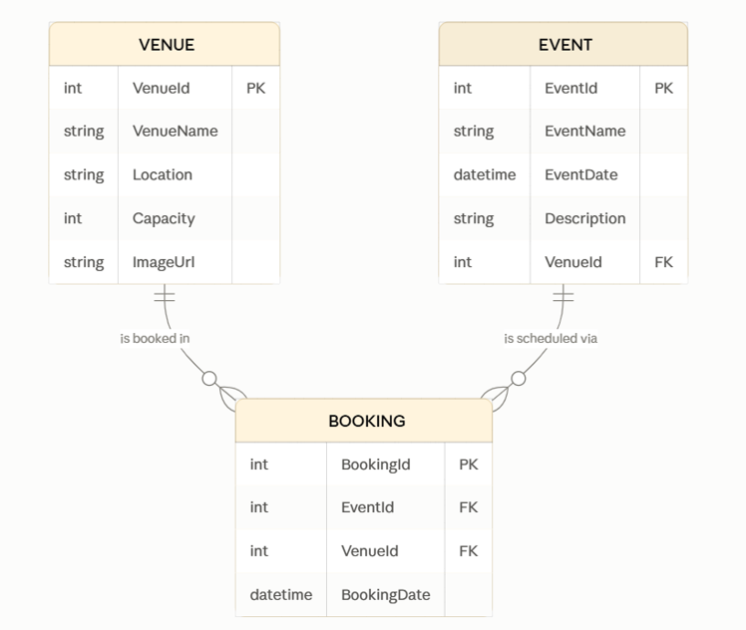

Database Scripting
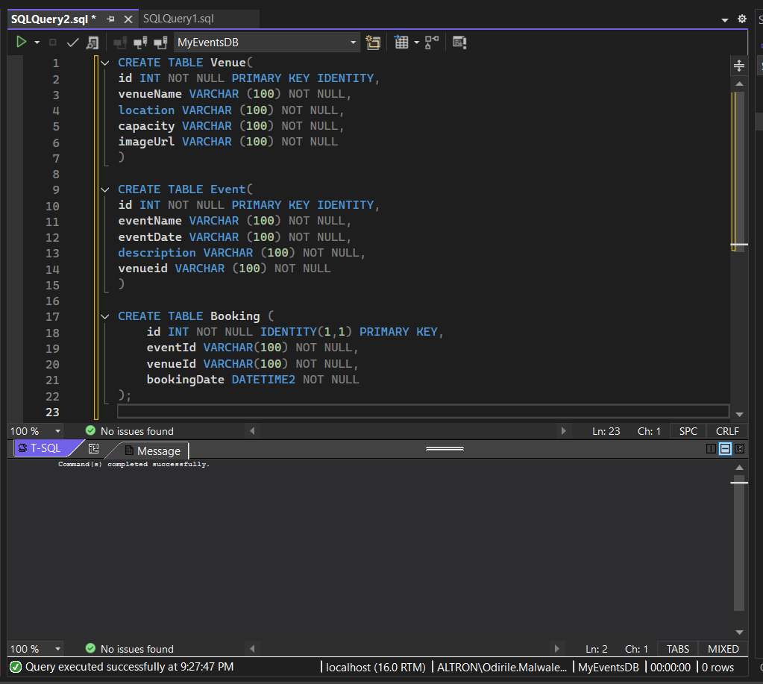
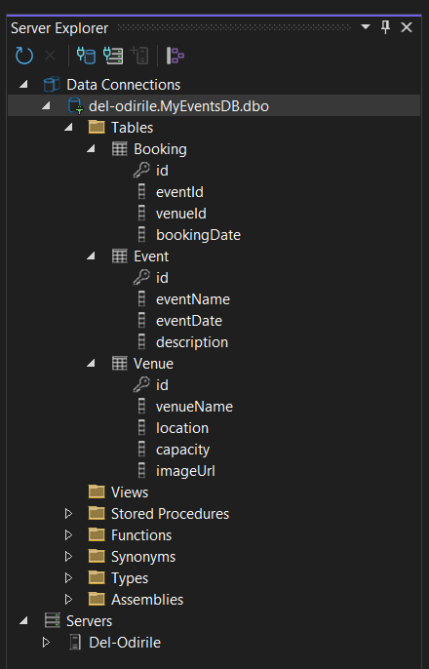

B. Web application development
The relevant Models, Controllers, and Views for each of the Venues, Events, and Bookings.
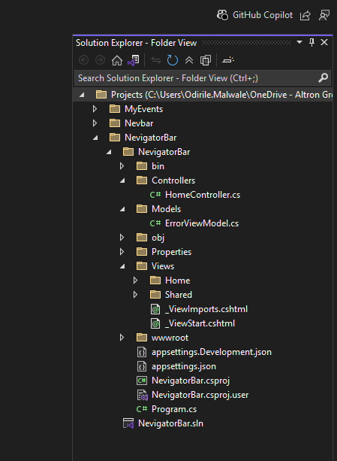

C. Deployment of the Web app and Database to Microsoft Azure
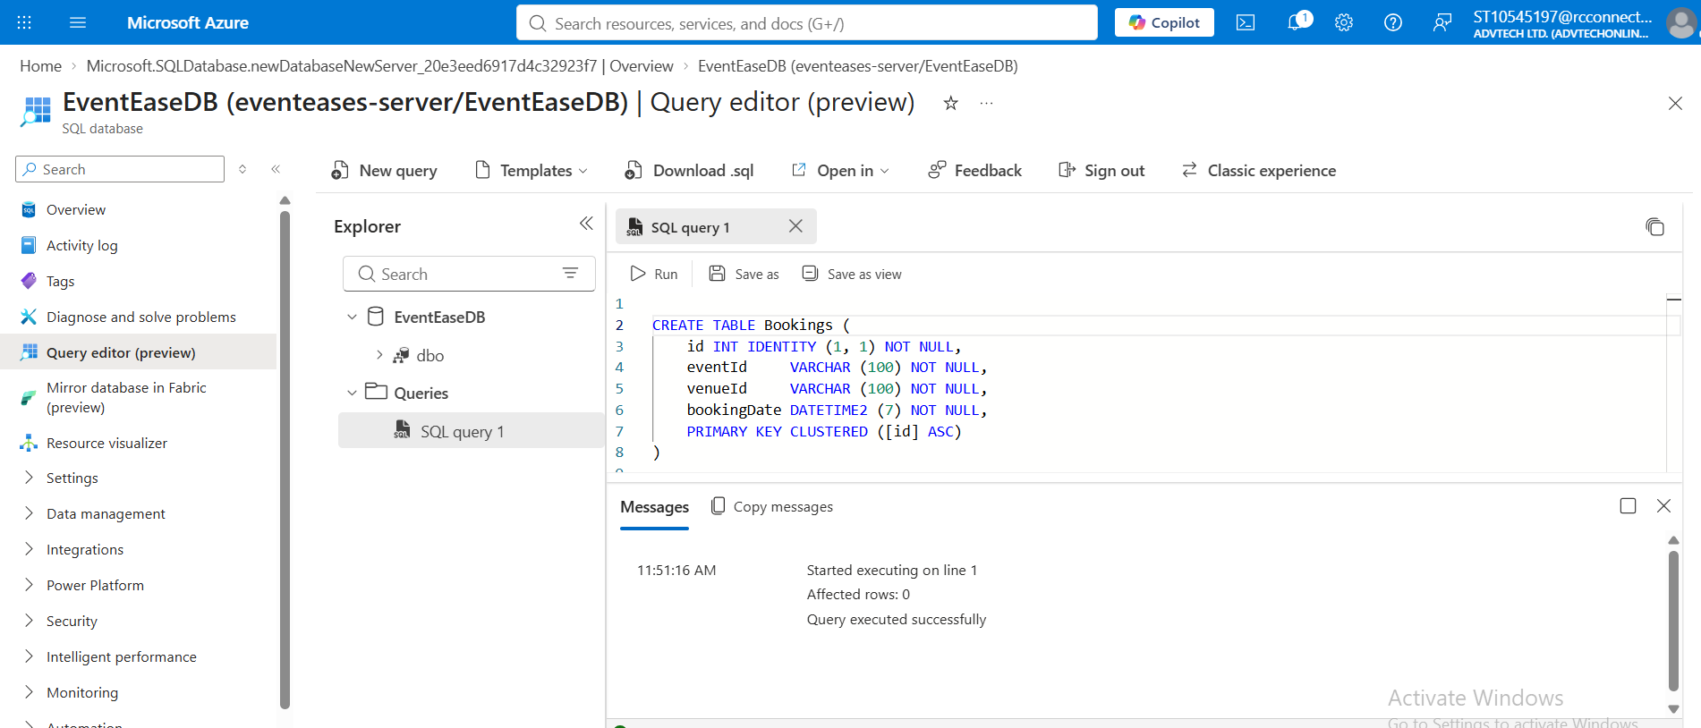
ADO.NET (SQL authentication) connection string
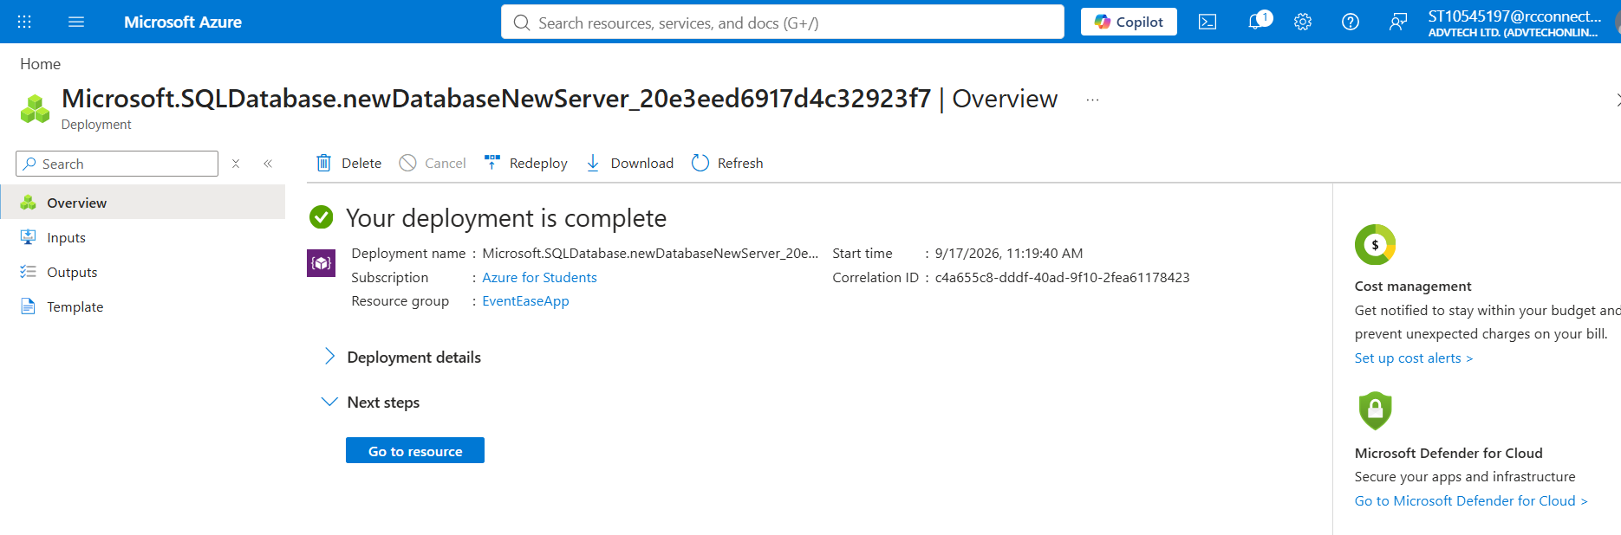
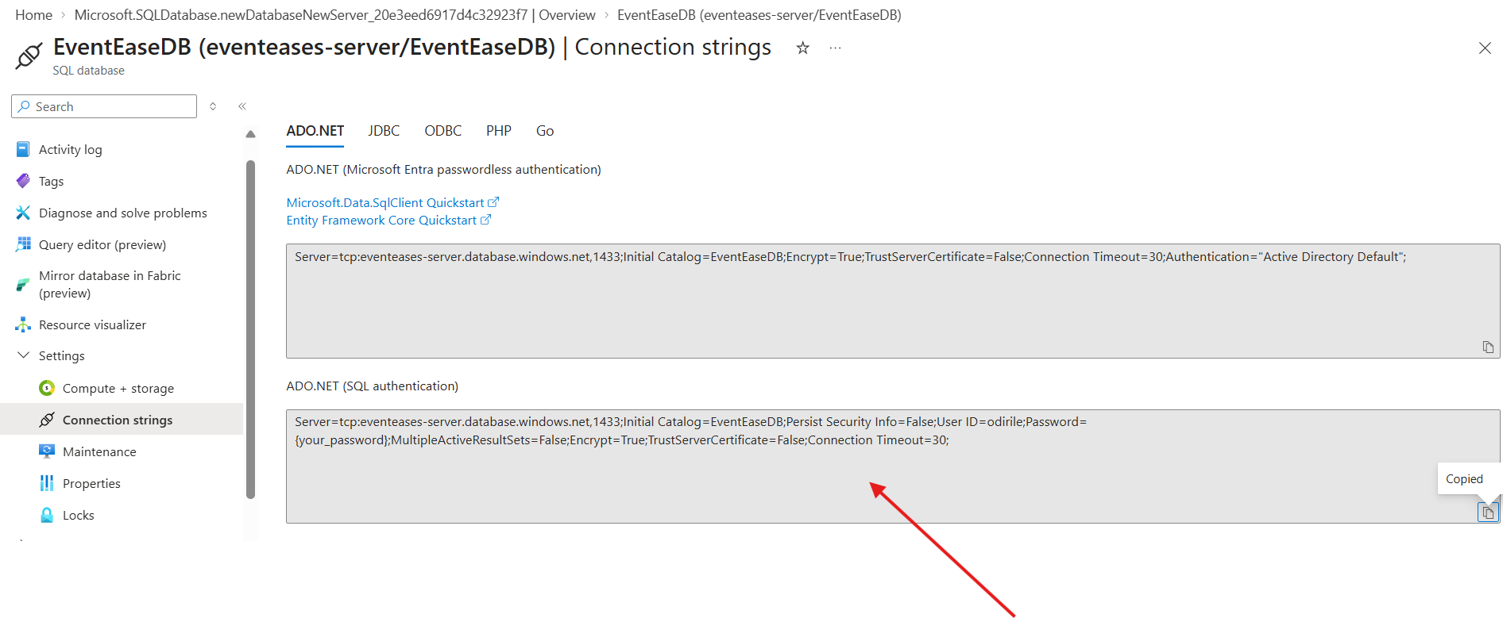

Updated the Connection string with the correct username and passwords.
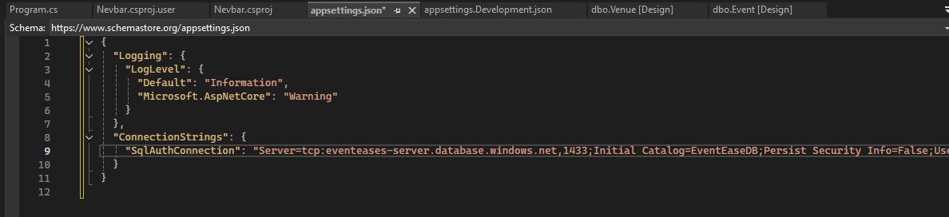
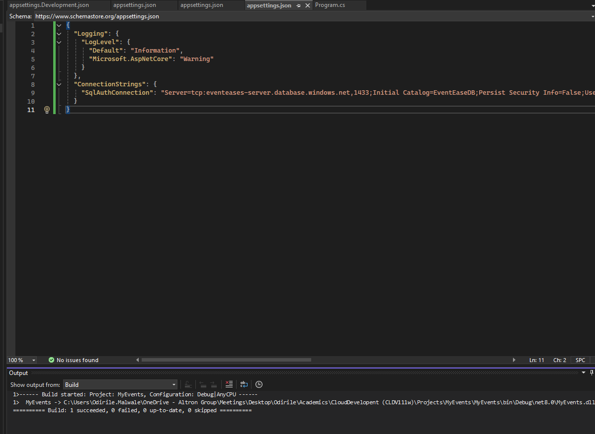
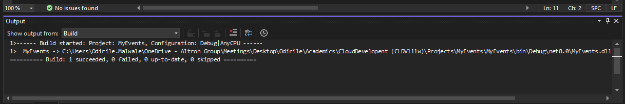

D. Cloud Computing Basics
1 .
On-premises
- You are in control of the entire stack, physical servers, network perimeter, hardware lifecycle, and software.
- You get full control and full responsibility. If your firewall rules are misconfigured or a server room lacks proper physical access controls, that's entirely on your team to catch.
E.G A hospital running patient records on its own servers, for instance, might do this specifically so it never has to trust a third party with physically hosting sensitive data.
On-premises
- Deployment is bottlenecked by physical reality. Need more servers?
- Scaling for a seasonal traffic spike
E.G.A retailer preparing for Black Friday) means buying and provisioning that capacity in advance, often sitting idle the rest of the year.
2.
Infrastructure as a Service (IaaS) provides fundamental computing resources, virtual machines, storage, and networking.
PaaS (Platform as a Service): Provides a pre-configured hardware and software framework for developing, running, and managing applications without worrying about underlying servers or OS maintenance.
SaaS (Software as a Service): Delivers complete, fully managed, web-based applications ready for end users to access via a web browser or app interface.
EventEase benefits from the use or IassS, PaaS and SaaS
On-Demand Infrastructure Scaling (IaaS): You can dynamically spin up virtual servers during ticket sales or large-scale events to handle sudden traffic spikes without purchasing permanent hardware.
Cost-Effective Resource Allocation (IaaS): Pay only for the computing power and cloud storage used during active event planning and production, significantly reducing off-season operational overhead.
Reliable Cloud Backups & Disaster Recovery (IaaS): Securely back up critical event data, guest lists, and production assets across multiple offsite data centers to ensure business continuity if physical hardware fails.
Rapid App Development for Events (PaaS): Developers can quickly build and deploy custom event-branded mobile apps or guest check-in tools without spending time configuring underlying servers.
Simplified API Integration (PaaS): Easily connect application features—such as payment gateways, SMS notification systems, and badge-scanning tools—into your custom event platform using built-in development environments.
Automated Backend Maintenance (PaaS): Cloud providers manage database updates, operating system patches, and security frameworks automatically, letting your tech team focus strictly on improving attendee experience.
Centralized Team Collaboration (SaaS): Utilize tools like Google Workspace or Microsoft 365 to collaborate on event run-sheets, floor plans, and schedules in real time from anywhere.
Streamlined Event Management & Ticketing (SaaS): Deploy ready-to-use platforms like Eventbrite, Cvent, or Bizzabo to handle registration, ticketing, session scheduling, and badge printing with zero software setup.
Automated Client & Lead Tracking (SaaS): Track corporate client relationships, vendor contracts, and marketing leads seamlessly using Cloud CRMs like Salesforce or HubSpot.
Real-Time Financial & Vendor Management (SaaS): Automate client invoicing, budget tracking, and vendor payments through cloud accounting software like QuickBooks Online or Xero.

